**Python Basics : one week**

**DEMO**

**1 Installation, Expression, Data types, Variables, Execution**

**2 Operators and Flow Controls (If, if-else)**

**3 Loops for, while, Range( Examples) and**

**4 Functions and Collections( List, tuple, Dictionary)**

Python Modules: From Wed : 9.30 to 11am

String and

Regular expression

Files

Debugging and Functions

Collections

OOPS

<2 years

Python with Django :

2+ Years

Python with Data Scientist

Python with Aws/Devops

Python with Big data Hadoop

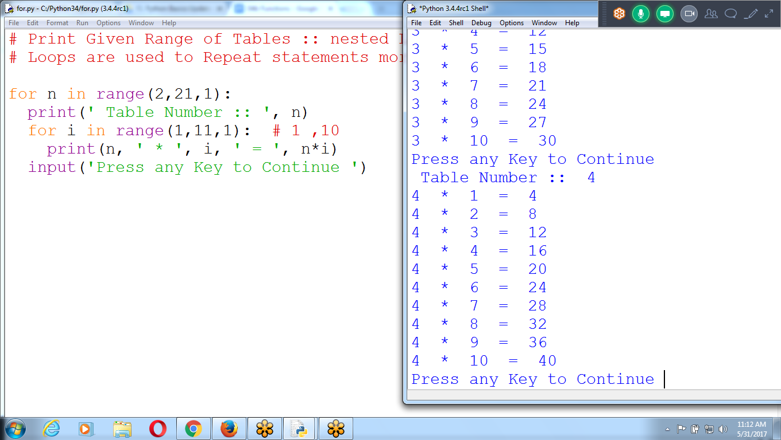

# **Python Functions**

A ***function*** is like a mini-program within a program.

* Previously discussed print(), input(), and len() functions in which Python provides several built in functions.
* A major purpose of functions is to **group code** that gets **executed multiple times**
* Without a function defined, you would have to copy and paste this code each time
* Want to avoid duplicating code, have to remember to change the code everywhere you copied it

A ***parameter*** is a variable that an argument is stored in when a function is called.

* Value stored in a parameter is forgotten when the function returns
* similar to how a program’s variables are forgotten when the program terminates.

# **Return Values and return Statements**

When creating a function using the def statement, you can specify what the return value should be with a **return statement**. A return statement consists of the following:

* The return keyword
* The value or expression that the function should return

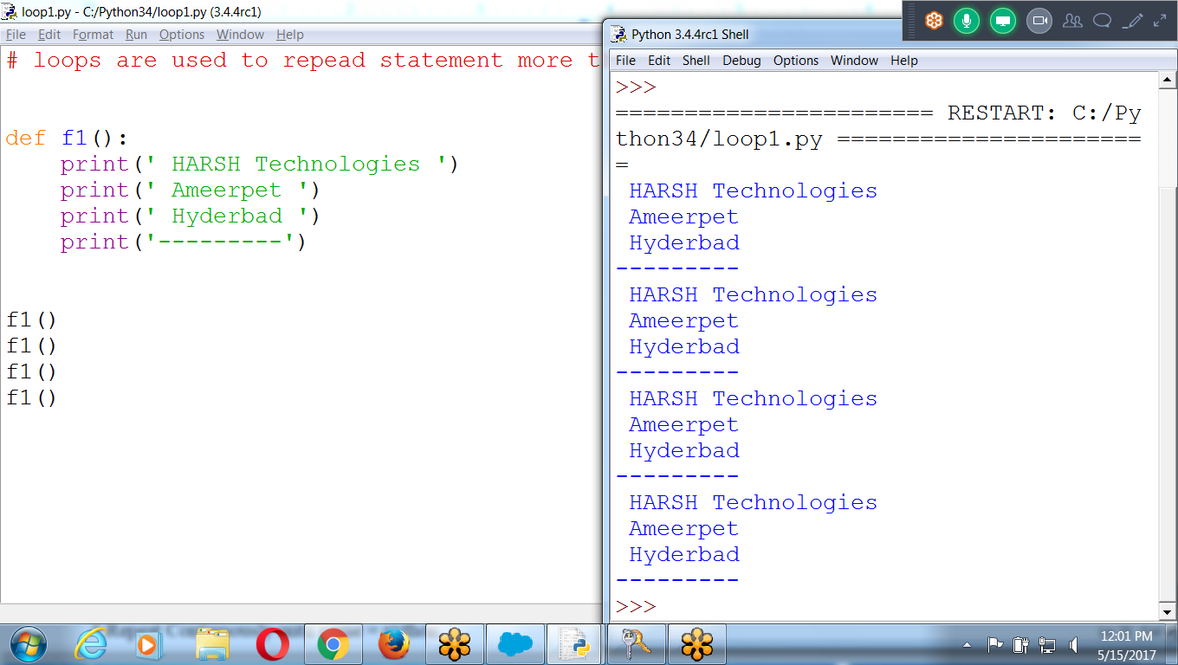

# loops are used to repeat statement more than once

def f1():

print(' HARSH Technologies ')

print(' Ameerpet ')

print(' Hyderbad ')

print('---------')

f1()

f1()

f1()

f1()

**Passing Parameter to a function**

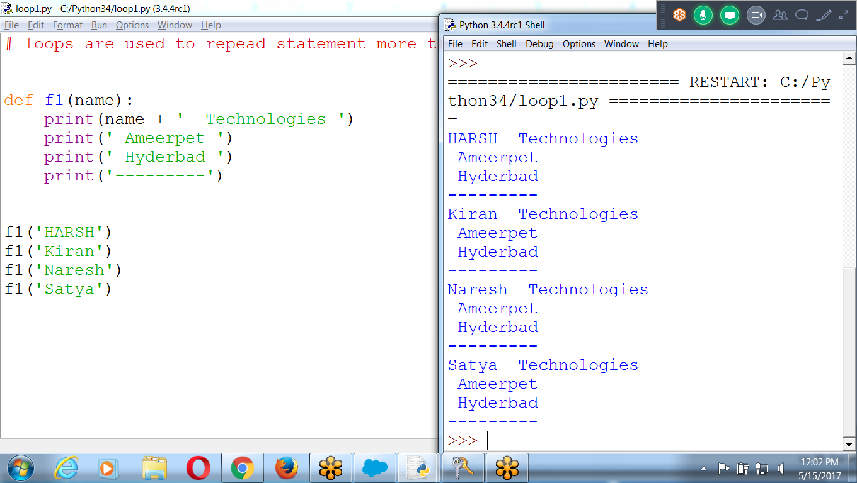

# Function is a BLOCK of statements

def f1(name):

print(name + ' Technologies ')

print(' Ameerpet ')

print(' Hyderbad ')

print('---------')

f1('HARSH')

f1('Kiran')

f1('Naresh')

f1('Satya')

Input Institute Name 3 times and print Address

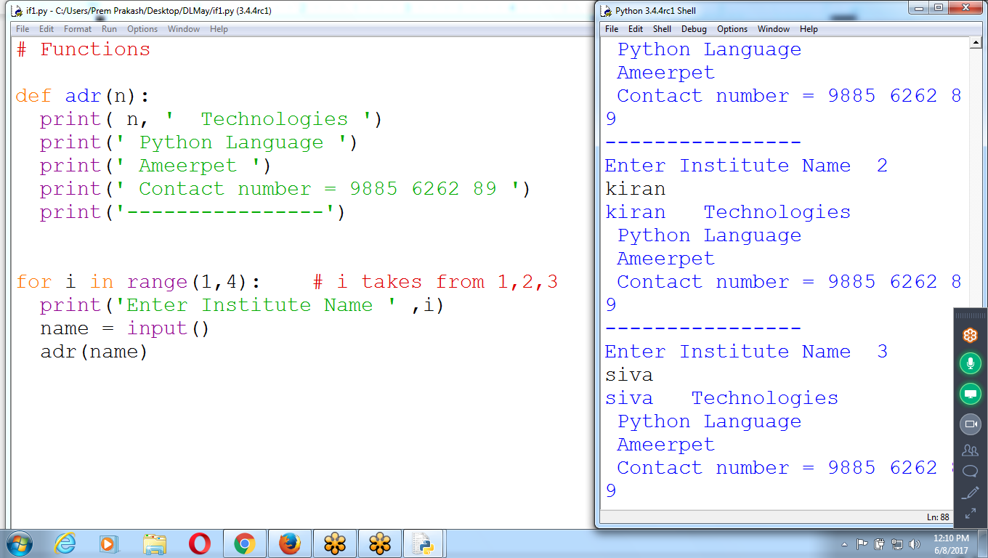

# Functions

def adr(n):

print( n, ' Technologies ')

print(' Python Language ')

print(' Ameerpet ')

print(' Contact number = 9885 6262 89 ')

print('----------------')

for i in range(1,4): # i takes from 1,2,3

print('Enter Institute Name ' ,i)

name = input()

adr(name)

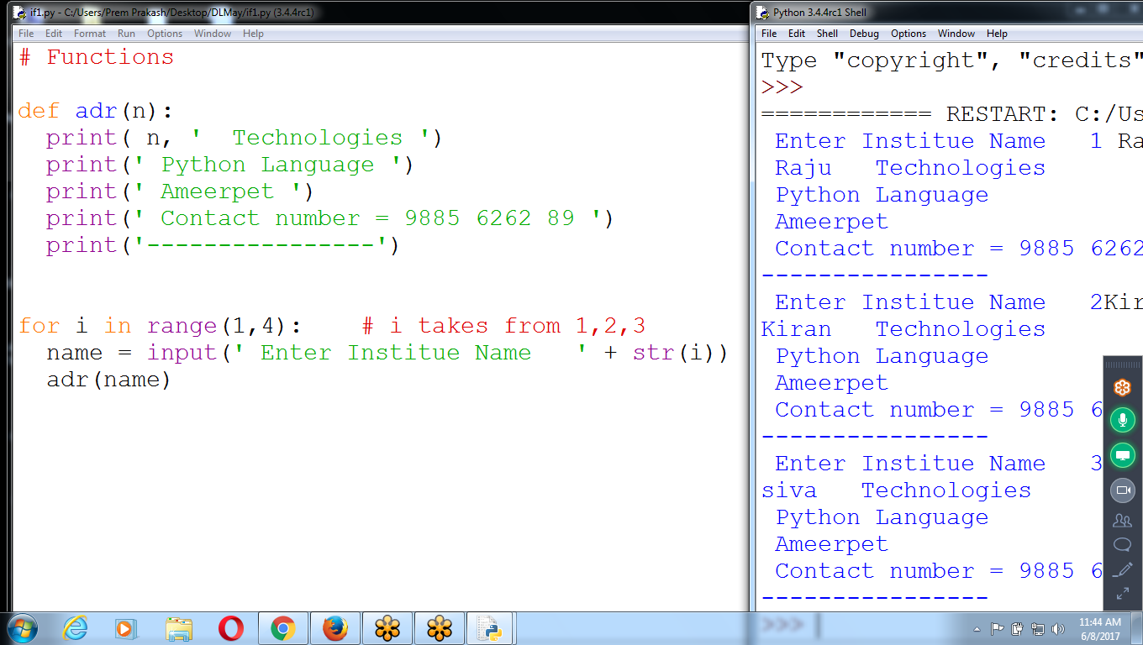

# Functions

def adr(n):

print( n, ' Technologies ')

print(' Python Language ')

print(' Ameerpet ')

print(' Contact number = 9885 6262 89 ')

print('----------------')

for i in range(1,4): # i takes from 1,2,3

name = input(' Enter Institue Name ' + str(i))

adr(name)

**INput 3 Employee Names, id,bs and RETURN “ NEt salary”**

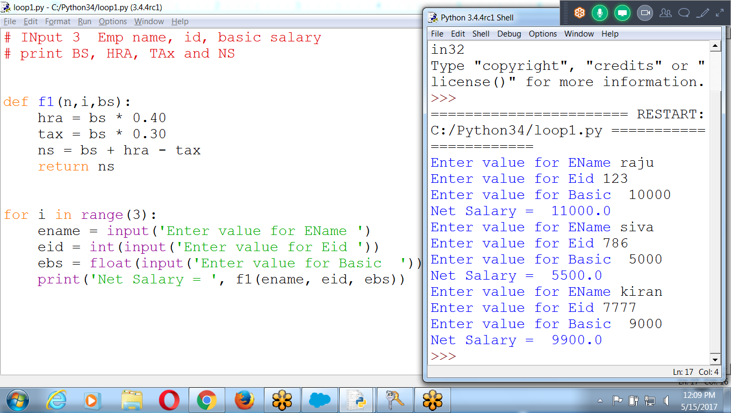

# INput 3 Emp name, id, basic salary

# print BS, HRA, TAx and NS

def f1(n,i,bs):

hra = bs * 0.40

tax = bs * 0.30

ns = bs + hra - tax

return ns

for i in range(3):

ename = input('Enter value for EName ')

eid = int(input('Enter value for Eid '))

ebs = float(input('Enter value for Basic '))

print('Net Salary = ', f1(ename, eid, ebs))

**Find Factorial of given number, until user press ‘0’**

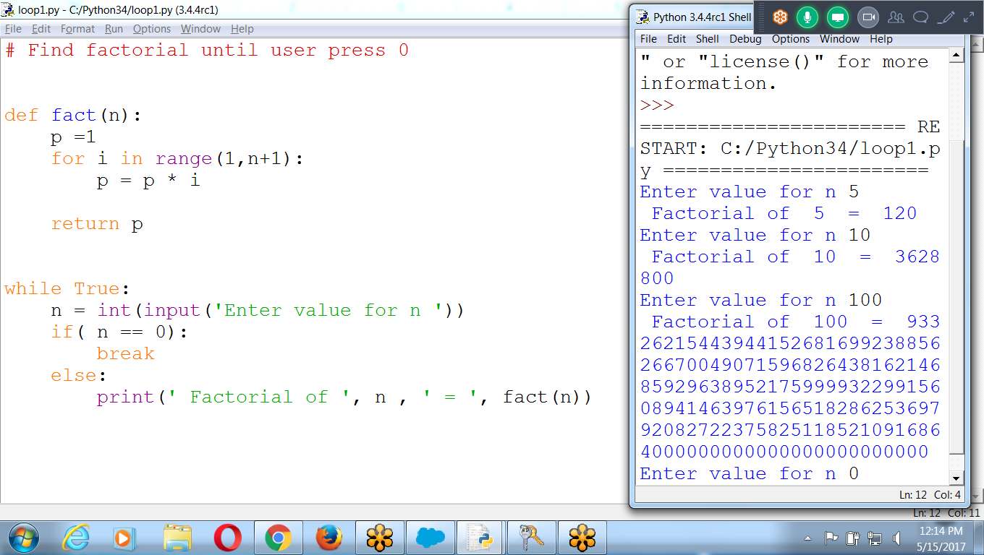

# Find factorial until user press 0

def fact(n):

p =1

for i in range(1,n+1):

p = p * i

return p

while True:

n = int(input('Enter value for n '))

if( n == 0):

break

else:

print(' Factorial of ', n , ' = ', fact(n))

Print Table

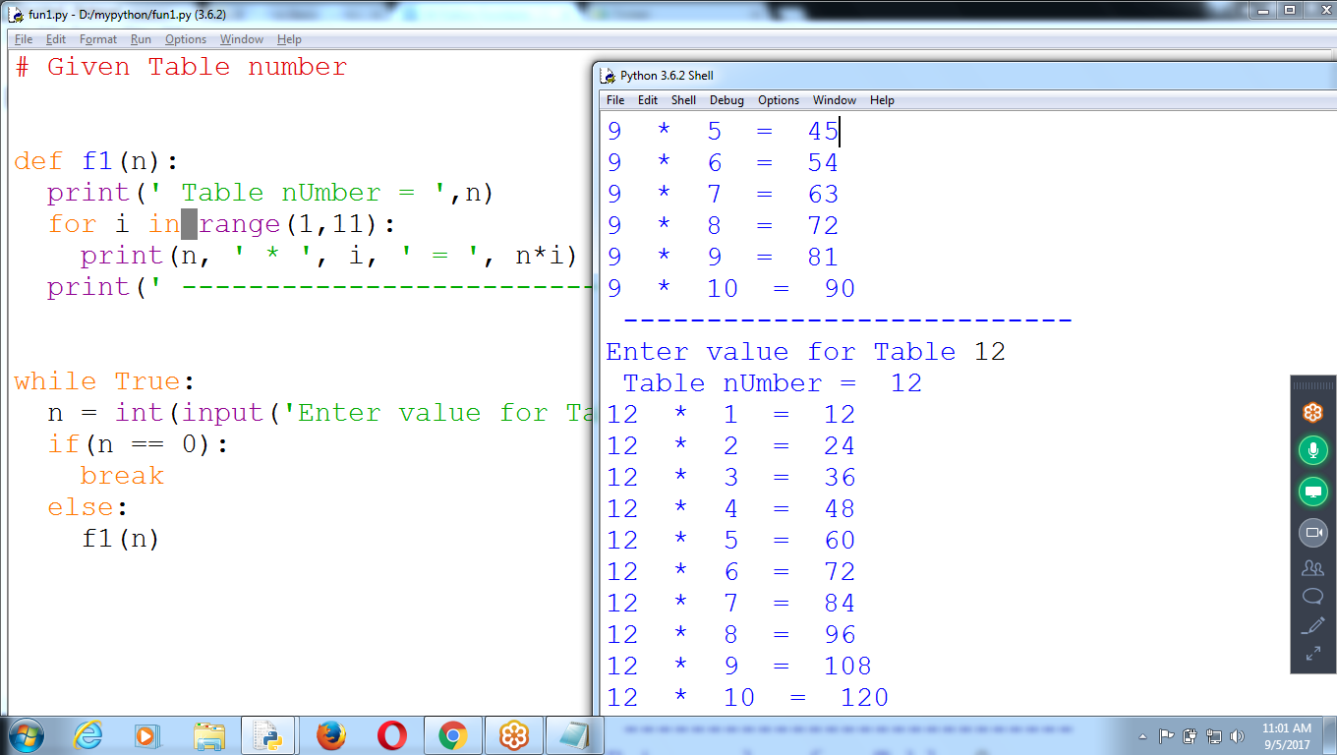

To RUN python programs WEB Based, without PYTHON Installation

**Trinket.io**

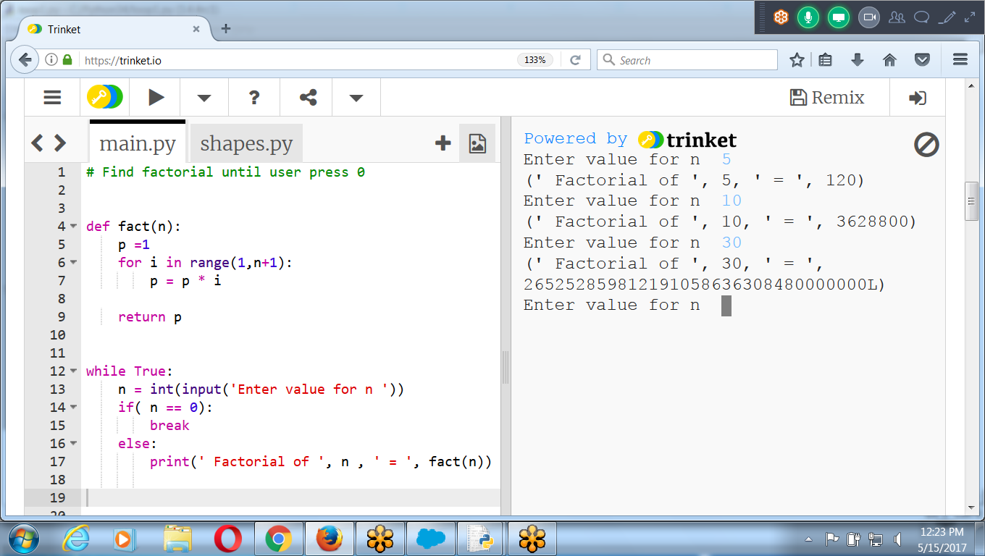

**********************************************************************************************************************************************************************************************

**Other Examples**

Program returns a Month string depending on what number it is passed as an argument.

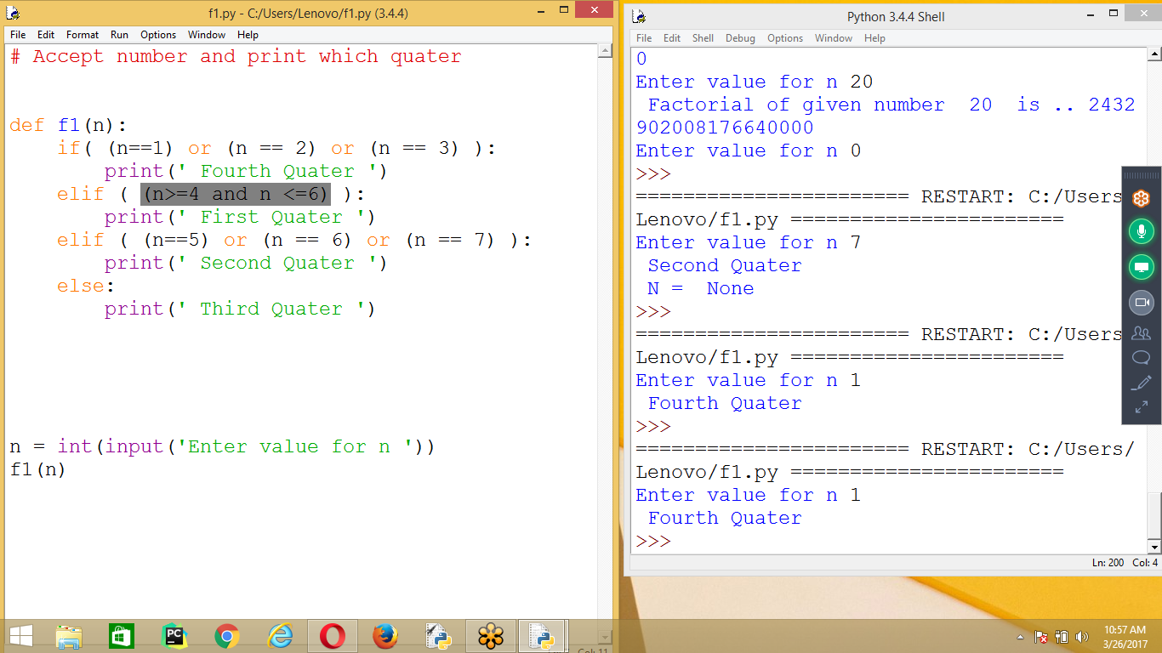

**Continue**

* When the program execution reaches a continue statement,

the program execution immediately jumps back to the start of the loop and reevaluates the loop’s condition.

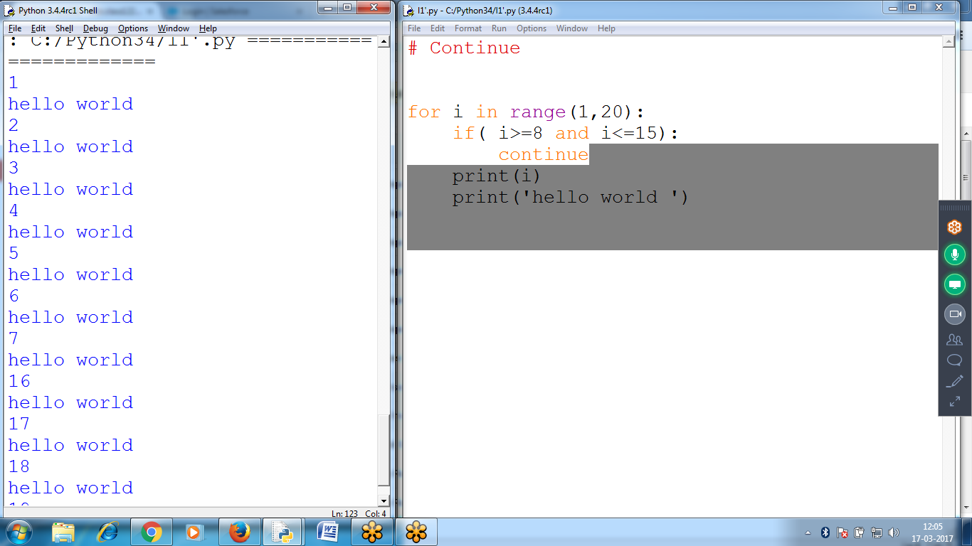

**# Program to ACCEPT uid AND pwd UNTIL criteria satisfies**

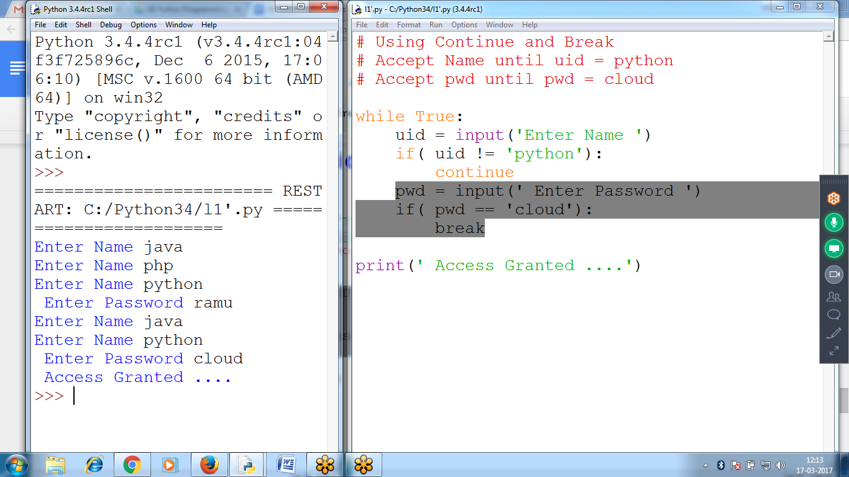

**# Using Continue and Break**

**# Accept Name until uid = python**

**# Accept pwd until pwd = cloud**

**while True:**

**uid = input('Enter Name ')**

**if( uid != 'python'):**

**continue**

**pwd = input(' Enter Password ')**

**if( pwd == 'cloud'):**

**break**

**print(' Access Granted ....')**

# 